Lab - Basic Switch and End Device Configuration

# Topology

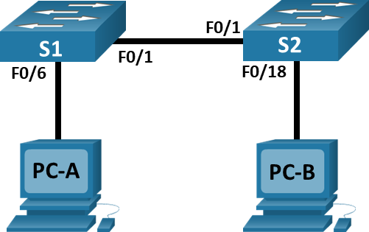

# Addressing Table

|  |  |  |  |
| --- | --- | --- | --- |
| Device | Interface | IP Address | Subnet Mask |
| S1 | VLAN 1 | 192.168.1.1 | 255.255.255.0 |
| S2 | VLAN 1 | 192.168.1.2 | 255.255.255.0 |
| PC-A | NIC | 192.168.1.10 | 255.255.255.0 |
| PC-B | NIC | 192.168.1.11 | 255.255.255.0 |

# Objectives

* Set Up the Network Topology
* Configure PC Hosts
* Configure and Verify Basic Switch Settings

# Background / Scenario

In this lab, you will build a simple network with two hosts and two switches. You will also configure basic settings including hostname, local passwords, and login banner. Use **show** commands to display the running configuration, IOS version, and interface status. Use the **copy** command to save device configurations.

You will apply IP addressing for this lab to the PCs and switches to enable communication between the devices. Use the **ping** utility to verify connectivity.

**Note**: The switches used are Cisco Catalyst 2960s with Cisco IOS Release 15.0(2) (lanbasek9 image). Other switches and Cisco IOS versions can be used. Depending on the model and Cisco IOS version, the commands available and output produced might vary from what is shown in the labs.

**Note**: Make sure that the switches have been erased and have no startup configurations. Refer to Appendix A for the procedure to initialize and reload a switch.

# Required Resources

* 2 Switches (Cisco 2960 with Cisco IOS Release 15.0(2) lanbasek9 image or comparable)
* 2 PCs (Windows with terminal emulation program, such as Tera Term)
* Console cables to configure the Cisco IOS devices via the console ports
* Ethernet cables as shown in the topology

# Instructions

## Set Up the Network Topology

In this step, you will cable the devices together according to the network topology.

* + 1. Power on the devices.
    2. Connect the two switches.
    3. Connect the PCs to their respective switches.
    4. Visually inspect network connections.

## Configure PC Hosts

* + 1. Configure static IP address information on the PCs according to the Addressing Table.
    2. Verify PC settings and connectivity.

## Configure and Verify Basic Switch Settings

* + 1. Console into the switch. Enter the global configuration mode.

Open Configuration Window

* + 1. Give the switch a name according to the Addressing Table.
    2. Prevent unwanted DNS lookups.
    3. Enter local passwords. Use **class** as the privileged EXEC password and **cisco** as the password for console access.
    4. Configure and enable the SVI according to the Addressing Table.
    5. Enter a login MOTD banner to warn about unauthorized access.
    6. Save the configuration.
    7. Display the current configuration.
    8. Display the IOS version and other useful switch information.
    9. Display the status of the connected interfaces on the switch.

Close Configuration Window.

* + 1. Configure switch S2.
    2. Record the interface status for the following interfaces.

| Interface | S1 Status | S1 Protocol | S2 Status | S2 Protocol |
| --- | --- | --- | --- | --- |
| F0/1 | blank | blank | blank | blank |
| F0/6 | blank | blank | blank | blank |
| F0/18 | blank | blank | blank | blank |
| VLAN 1 | blank | blank | blank | blank |

* + 1. From a PC, ping S1 and S2. The pings should be successful.
    2. From a switch, ping PC-A and PC-B. The pings should be successful.

# Reflection Question

Why some FastEthernet ports on the switches are up and others are down?

Type your answers here.

What could prevent a ping from being sent between the PCs?

Type your answers here.

End of Document